# Introduction to Data Management

**PROJECT REPORT**

(Project Semester January-April 2025)

***Demographic Analysis of Chronic Diseases in the United States: An Interactive Dashboard Approach***

Submitted by

Aniket Sharma

Registration No: 12308331 Section: K23EG

Programme: B. Tech - Computer Science and Engineering Course Code: INT217

Under the Guidance of

**Jaffar Amin Chacket (UID: 30453) Discipline of CSE/IT**

**Lovely School of Computer Science and Engineering Lovely Professional University, Phagwara**



**CERTIFICATE**

This is to certify that Aniket Sharma bearing Registration no. 12308331 has completed INT217 (Introduction to Data Management) project titled, **“Demographic Analysis of Chronic diseases in the United States: An Interactive Dashboard Approach”** under my guidance and supervision. To the best of my knowledge, the present work is the result of his/her original development, effort and study.

**Signature**

**Jaffar Amin Chacket (UID: 30453)**

**School of Computer Science and Engineering**

Lovely Professional University Phagwara, Punjab.

Date:

**DECLARATION**

I, Aniket Sharma, student of B.Tech Computer Science and Engineering under CSE/IT Discipline at, Lovely Professional University, Punjab, hereby declare that all the information furnished in this project report is based on my own intensive work and is genuine.

Aniket Sharma 12311354 – K23EG

B. Tech - Computer Science and Engineering Lovely Professional University, Phagwara



09/04/2025

# Acknowledgement

The opportunity of attaining a course based on Data Management using Excel at Lovely Professional University was worth learning. It was a prestige for me to be part of it. During the period of my course, I received tremendous knowledge related to Microsoft Excel and Data Management.

Pre-eminently, I would like to express my deep gratitude and special thanks to my course teacher Sameeksha Khare for her theoretical knowledge and encouragement on this project and for her valuable guidance and affection for the successful completion of this project.

Secondly, I would like to thank Lovely Professional University for giving me an opportunity to learn this course.

Lastly, I would like to thank the almighty and my parents for their constant encouragement, moral support, personal attention, and care.

Aniket Sharma 12308331 – K23EG

B. Tech - Computer Science and Engineering Lovely Professional University, Phagwara

# Contents

|  |  |  |
| --- | --- | --- |
| Sr. No. | Topic | Page No. |
| 1. | Cover Page | 1 |
| 2. | Certificate | 2 |
| 3. | Declaration | 3 |
| 4. | Acknowledgement | 4 |
| 5. | Contents | 5 |
| 6. | Abstract | 6 |
| 7. | Report | 7 |

**Abstract**

Excel is a software program created by Microsoft that uses spreadsheets to organize numbers and data with formulas and functions. Excel analysis is ubiquitous around the world and used by businesses of all sizes to perform data analysis. Excel features calculation, graphing tools, pivot tables, and a macro programming language called Visual Basic for Applications, and several other features which make Excel a perfect choice to manage and analyse data.

My project is an Excel Dashboard. The Excel Dashboard is used to display overviews of large data tracks. Excel Dashboards use dashboard elements like tables, charts, and gauges to show the overviews. The dashboards ease the decision-making process by showing the vital parts of the data in the same window.

In this report, I have shared a project where I have done data analysis of Chronic disease dataset across US States. This report also presents my learning during my course classes.

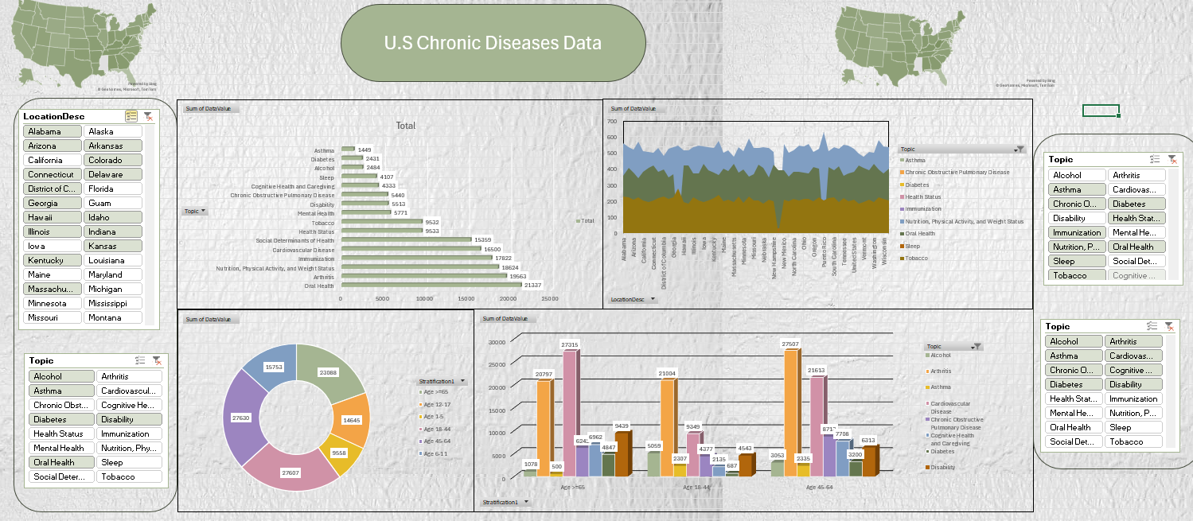

This is how my main dashboard looks like . given below are some more screenshots of dashboard.

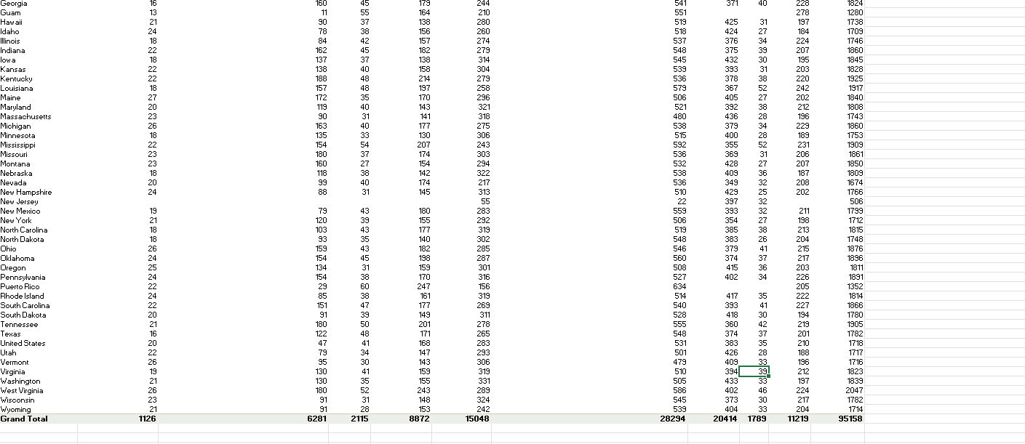

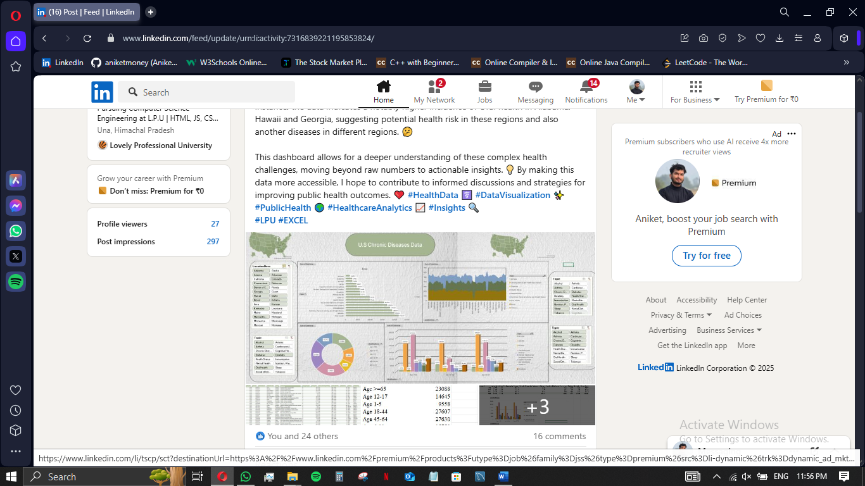

This is the screenshot of my uploaded work

.